**Bracings:**

To manage seismic and wind loads in a pre-engineered building, different forms of bracings are used. The most common is cross bracing. Using solid rods, angles, or cables, each brace is fastened to the top and bottom of the main frame making an ‘X’ between the two rigid frames. Depending on the size and height of the building, and on the wind and seismic loads, the number of braced bays required will vary but at a minimum one bay per side is required.

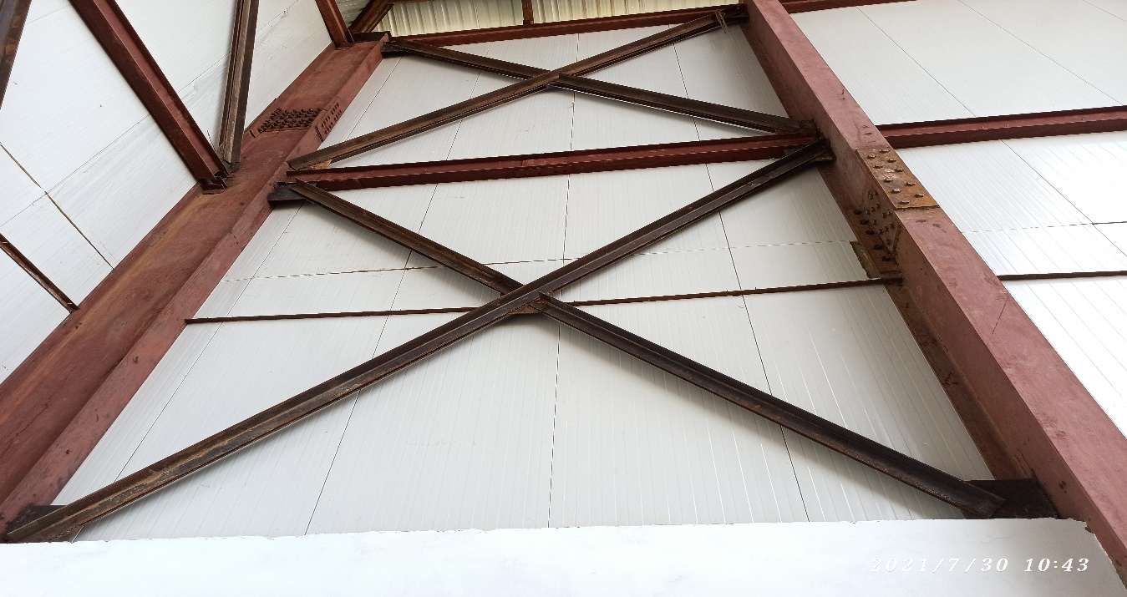

Bracings

**Truss:**

A truss is a structure that consists of members organized into connected triangles so that the overall assembly behaves as a single object. Trusses are most commonly used in bridges, roofs and towers. A truss is a web of triangles joined together to enable the even distribution of weight and the handling of changing tension and compression without bending and shear. All the joints are pin joints. All the members are straight. Generally, the overall efficiency of a truss is optimized by using less material in the chords and more in the bracing elements.

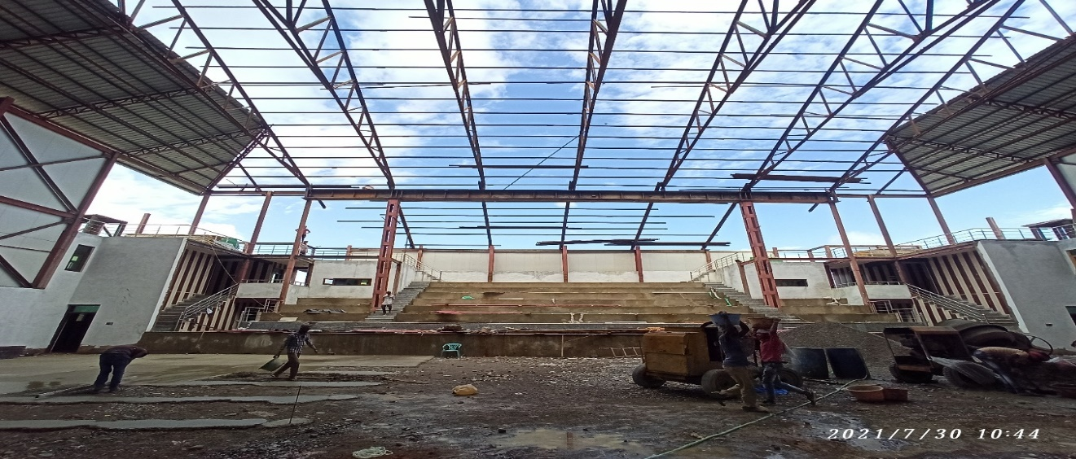

Truss

**Anchor bolts:**

Anchor bolts are used to connect structural and non-structural elements to concrete. The connection can be made by a variety of different components. The following anchor bolt types represent commonly used fixing to the concrete foundation: hooked bars for light anchoring, cast-in-place headed anchors and anchors bonded to drilled holes. When it is necessary to transfer a big force, more expensive anchoring systems are used.

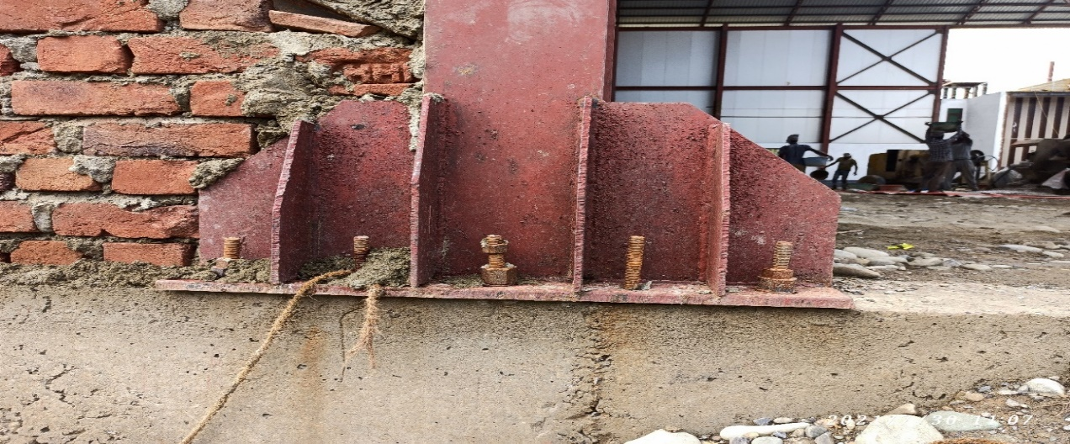

Anchor bolts

**PUF panel:**

Construction trend has changed these days. Nowadays PUF panels are used in both walls and roofing. PUF panels are an acronym of polyurethane foam which is a layer of material sandwiched between two GI metal sheets. The foaming material ensures proper insulation from heat as well as from cold, maintaining the room temperature inside. These insulated sandwich panels can be integrated using joists and studs. These structures have a huge demand in the market owing to their durability and high strength.

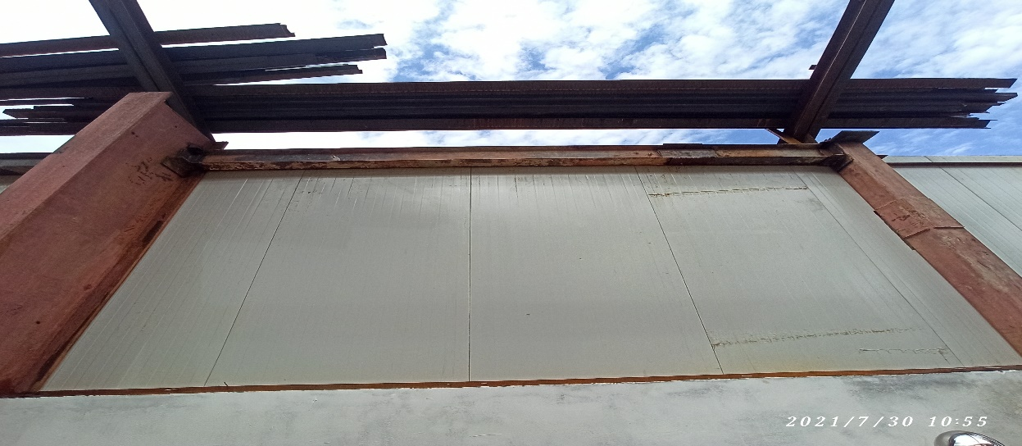

PUF wall panel

**Cleats:**

Cleat is ideal for making joints, connections with Cee or Zed sections / purlins. Often found connecting wall girts to columns, roof battens or roof purlins to rafters and the like. The holes punched in the assorted size GPB brackets are punched to match standard purlin punching in the ends of purlins of a matching size.

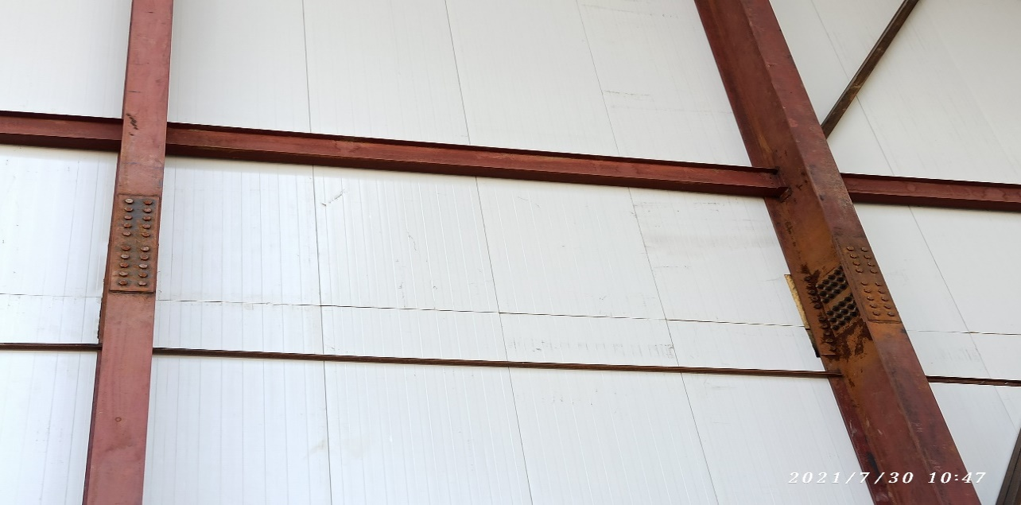

Cleat